Rafferty
6E
News Release

FOR IMMEDIATE RELEASE
Contact: Karissa Rafferty, kraffert@gmu.edu
Is George Mason University Campus Truly Safe?
David Farris, Mason alumni, spoke to students on his job role in maintaining and improving campus awareness in emergency weather situations.

(Fairfax, VA – September 12, 2012) –The manager of Emergency Preparedness and Response came to speak with a Communication 391 class at George Mason University.
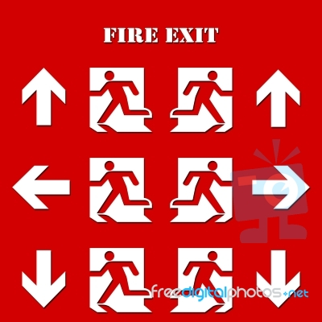
“George mason’s footprint doesn’t just stop at the boundaries. We make decisions that impact everyone else around campus,” says David Farris, on the unlimited repercussions of emergency situational response.
Farris also spoke about the importance of perspective, and being able to predict how your audience will receive vital information in natural disasters such as tornadoes, earthquakes and fires. Since the birth of his 14 month old daughter, “I have a whole different perspective on the increased value of the human population,” David Farris quotes about the profound event that has impacted his perspective on life’s worth.

Based on David Farris’ work experience in directing George Mason’s Emergency Response Center, he has come to the conclusion that “People are more interested in timely information rather than correct information. We would rather have information right away and get the right info later.” He has to make assumptions based on the most current information at the time of emergencies, in hopes of limiting potential liabilities among the public.

On being asked what a typical day at the office is like, David Farris responds, “A LOT of meetings. I will stress this no matter what major you go into: I suggest active listening. Second, technical writing is extremely important. I cannot stress that importance.”

###

